**SALES DASHBORAD**

**KPI Cards**

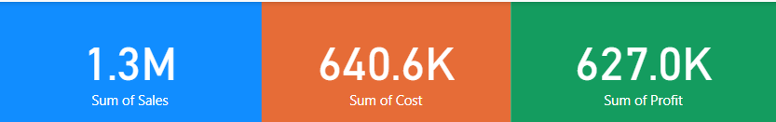

**1.List of company customers**

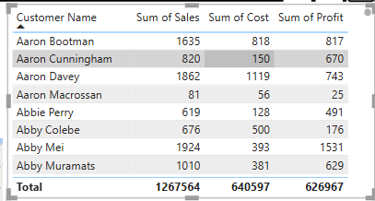

* Top sales performing country:Spain
* Least sales performing country:Sweden
* Top sum of profit performing country:UK
* Least sum of profit performing country:Germany
* Top sum of cost performing country:France
* Least sum of cost performing country:Norway

**2.Map**

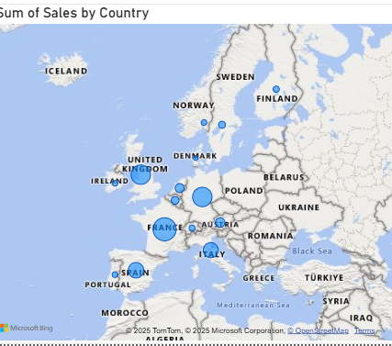

* Top sales performing country:Spain
* Least sales performing country:Sweden

**3.column chart**

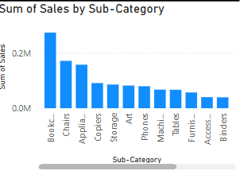

**Top 3 sub-category:**

* Bookcases :Sum of sales:273666
* Chairs :sum of sales:171275
* Appliances :sum of sales:157411

Least sub-category:Binder

Sum of sales:39240

**4.pie chart**

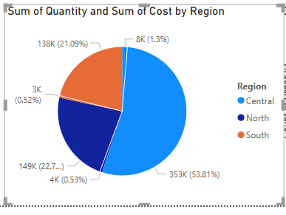

* Highest sum of sales:central
* Least sum of sales:south

**5.line chart**

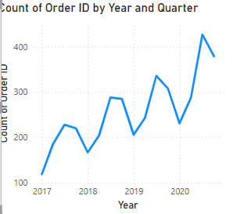

* Highest count of order :2020 Qtr3
* Orderid :427
* Least count of order:2017 Qtr1
* Orderid :119